**Analysis report on the basis of the spending score**

***Group by gender and find*** ***average spending score.***

+------+------------------+

| Genre| avg(Score)|

+------+------------------+

|Female|51.526785714285715|

| Male| 48.51136363636363|

+------+------------------+

Female customers have higher average spending score as compared to male customers.

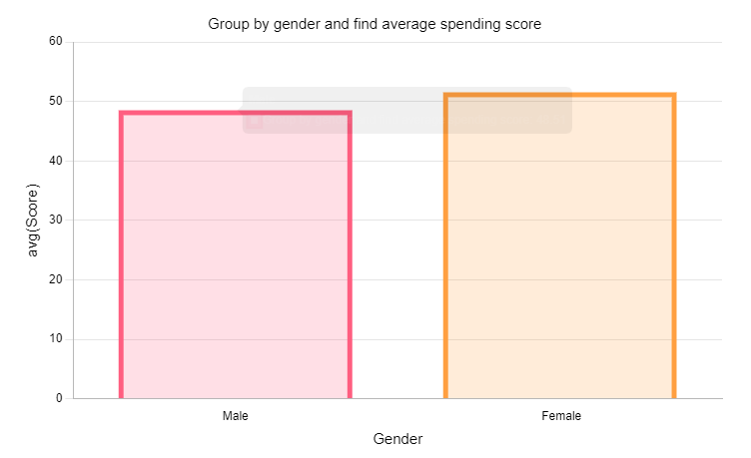

***Filter out customers having spending score greater than 50.***

+----------+------+---+------------------+-----+

|CustomerID| Genre|Age|Annual Income (k$)|Score|

+----------+------+---+------------------+-----+

| 2| Male| 21| 15| 81|

| 4|Female| 23| 16| 77|

| 6|Female| 22| 17| 76|

| 8|Female| 23| 18| 94|

| 10|Female| 30| 19| 72|

| 12|Female| 35| 19| 99|

| 14|Female| 24| 20| 77|

| 16| Male| 22| 20| 79|

| 18| Male| 20| 21| 66|

| 20|Female| 35| 23| 98|

| 22| Male| 25| 24| 73|

| 24| Male| 31| 25| 73|

| 26| Male| 29| 28| 82|

| 28| Male| 35| 28| 61|

| 30|Female| 23| 29| 87|

| 32|Female| 21| 30| 73|

| 34| Male| 18| 33| 92|

| 36|Female| 21| 33| 81|

| 38|Female| 30| 34| 73|

| 40|Female| 20| 37| 75|

| 42| Male| 24| 38| 92|

| 44|Female| 31| 39| 61|

| 46|Female| 24| 39| 65|

| 47|Female| 50| 40| 55|

| 51|Female| 49| 42| 52|

| 52| Male| 33| 42| 60|

| 53|Female| 31| 43| 54|

| 54| Male| 59| 43| 60|

| 59|Female| 27| 46| 51|

| 61| Male| 70| 46| 56|

| 62| Male| 19| 46| 55|

| 63|Female| 67| 47| 52|

| 64|Female| 54| 47| 59|

| 65| Male| 63| 48| 51|

| 66| Male| 18| 48| 59|

| 69| Male| 19| 48| 59|

| 71| Male| 70| 49| 55|

| 74|Female| 60| 50| 56|

| 76| Male| 26| 54| 54|

| 77|Female| 45| 54| 53|

| 79|Female| 23| 54| 52|

| 81| Male| 57| 54| 51|

| 82| Male| 38| 54| 55|

| 85|Female| 21| 54| 57|

| 87|Female| 55| 57| 58|

| 88|Female| 22| 57| 55|

| 89|Female| 34| 58| 60|

| 91|Female| 68| 59| 55|

| 96| Male| 24| 60| 52|

| 103| Male| 67| 62| 59|

+----------+------+---+------------------+-----+

only showing top 50 rows

The above table shows customers having spending score greater than 50.

***Average spending score for people having age less than 35.***

+------------------+

| avg(Score)|

+------------------+

|60.449438202247194|

+------------------+

The average spending score for people having age less than is 60.449

***Average annual income for customers having spending score greater than 50.***

+-----------------------+

|avg(Annual Income (k$))|

+-----------------------+

| 60.41237113402062|

+-----------------------+

Average annual income for customers having spending score greater than 50 is 60k dollars.

***Top*** ***10 customers with highest spending score.***

+----------+------+---+------------------+-----+

|CustomerID| Genre|Age|Annual Income (k$)|Score|

+----------+------+---+------------------+-----+

| 12|Female| 35| 19| 99|

| 20|Female| 35| 23| 98|

| 146| Male| 28| 77| 97|

| 186| Male| 30| 99| 97|

| 128| Male| 40| 71| 95|

| 168|Female| 33| 86| 95|

| 8|Female| 23| 18| 94|

| 142| Male| 32| 75| 93|

| 164|Female| 31| 81| 93|

| 34| Male| 18| 33| 92|

+----------+------+---+------------------+-----+

only showing top 10 rows

The above table shows top 10 customers with highest spending score.

***Top 10 customers with lowest spending score.***

+----------+------+---+------------------+-----+

|CustomerID| Genre|Age|Annual Income (k$)|Score|

+----------+------+---+------------------+-----+

| 157| Male| 37| 78| 1|

| 159| Male| 34| 78| 1|

| 9| Male| 64| 19| 3|

| 31| Male| 60| 30| 4|

| 33| Male| 53| 33| 4|

| 135| Male| 20| 73| 5|

| 163| Male| 19| 81| 5|

| 141|Female| 57| 75| 5|

| 23|Female| 46| 25| 5|

| 3|Female| 20| 16| 6|

+----------+------+---+------------------+-----+

only showing top 10 rows

The above table shows 10 customers with lowest spending score.

***Group by age and find average spending score.***

+---+------------------+

|Age| avg(Score)|

+---+------------------+

| 31| 63.875|

| 65| 43.5|

| 53| 25.0|

| 34| 39.2|

| 28| 70.0|

| 27|60.333333333333336|

| 26| 54.5|

| 44| 13.5|

| 22| 70.0|

| 47| 28.5|

| 52| 21.0|

| 20| 40.2|

| 40| 47.5|

| 57| 28.0|

| 54| 35.75|

| 48| 41.8|

| 19| 39.75|

| 64| 3.0|

| 41| 28.0|

| 43| 34.0|

+---+------------------+

only showing top 20 rows

The above table shows customers grouped by age with their average spending score.

***Group by age class and average spending score for each class.***

+--------+------------------+

|AgeGroup| avg(Score)|

+--------+------------------+

| 49-58|36.964285714285715|

| 39-48| 37.65714285714286|

| 59-71|41.333333333333336|

| 18-28| 56.78|

| 29-38| 61.20634920634921|

+--------+------------------+

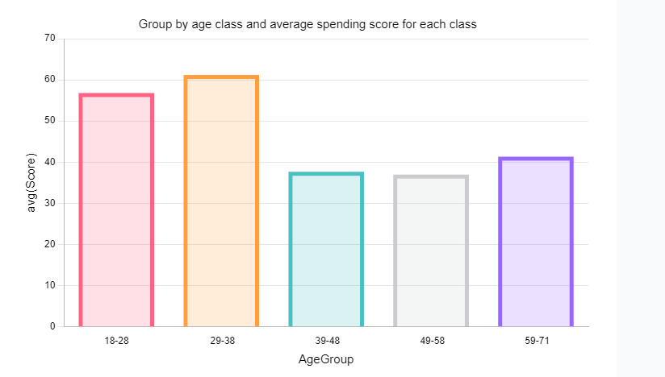

***Customer with maximum spending score.***

+----------+------+---+------------------+-----+

|CustomerID| Genre|Age|Annual Income (k$)|Score|

+----------+------+---+------------------+-----+

| 12|Female| 35| 19| 99|

+----------+------+---+------------------+-----+

Customer with customer ID 12 has the max. spending score.

***Customer with minimum spending score.***

+----------+-----+---+------------------+-----+

|CustomerID|Genre|Age|Annual Income (k$)|Score|

+----------+-----+---+------------------+-----+

| 157| Male| 37| 78| 1|

| 159| Male| 34| 78| 1|

+----------+-----+---+------------------+-----+

Customers with customer ID 157 and 159 have the min. spending score.

***Key Takeaways:***

1. Age group of 29-38 years has the maximum average spending score.
2. Female customers have higher average spending score as compared to male customers.
3. Customer with ID 12 has the maximum spending score.
4. Customers with ID 157 and 159 have the minimum spending score.
5. Average annual income for customers having spending score greater than 50 is 60k dollars.